Xtra! 4th June 2020
We cannot gather together in St John’s, but we can gather spiritually as we worship today. So first, refresh yourselves with something to eat and drink. It was Pentecost on Sunday so we are now in ordinary time which means we use a green cloth for our worship space. Why don’t you light a candle and make your space as we sing:
Gathering Song: Be Still and Know that I Am God
During which the table is set (green cloth) and candle is lit.
Greeting
Peace be with you
And also with you
Kyrie Confession
Introduce confession. Then children lead
Father God, we are sorry for the times when we have thought things that do not please you. [pause]
Lord have mercy
Lord have mercy
We are sorry for the times when we have said things that do not please you. [pause]
Christ have mercy
Christ have mercy
We are sorry for the times when we have done things that do not please you. [pause]
Lord have mercy
Lord have mercy
Absolution
May the God of love bring us back to himself,
forgive us our sins, and assure us of his eternal love
in Jesus Christ our Lord. Amen.
Gloria Peruvian Gloria
https://www.youtube.com/watch?v=Ep4TLwVM9mQ
Reading The Tall Tower
This story is from the same book that our creation and fall stories were from. Can you remember in which book in the Old Testament that is?
https://www.youtube.com/watch?v=CW-NXNzdZhM
Group Discussion
I wonder what your favourite part of this story is;
I wonder if it is possible to build such a tall tower;
I wonder if it is possible to be more important than God;
I wonder if it is possible to be more important than someone else;
I wonder who Jesus thought was important.
Activity: A choice
either Tower Building or Who is Most Important?
(or do both!)
Tower Building
Choose something you can build with (lego, wooden bricks, playing cards…) and see how tall a tower you can build. Is it as tall as you? Maybe it is even taller!

Who is Most Important?
Can you rank these people putting the most important first?
Either cut them out and move them around, or move them around with the mouse.

Homeless Person
Yourself

Your Mum
Your Best Friend
God
Refugee
Some people say that the story of Pentecost is a story that in some way reverses what happened at the Tower of Babel. When the Holy Spirit came suddenly everyone could understand what Peter was telling them about Jesus and lots of people believed him. If you’d like to read this story, it’s at the end of this service.
Song Another choice or both (or neither)!
♫ Jesus, name above all names
https://www.youtube.com/watch?v=RIxCcy7mKKk
♫ Who’s the king of the jungle https://www.youtube.com/watch?v=bzA6JBQur9A
Prayer
Dear God,
Help me to remember that Your Name
is the most IMPORTANT name for me to know.
Help me not to think that I am more important than other people.
Please help me to build my life on your foundation.
I praise You and give You all the glory.
In Jesus' Name. Amen.
Lord’s Prayer choose which version you would like to say
Blessing
May the lightness of God go with you
May the brightness of God go with you
May he shine on all you do. May God bless you.
Messy Grace
Resources:
Refreshments; Green cloth, candle, matches…
Activity resource: something to build with
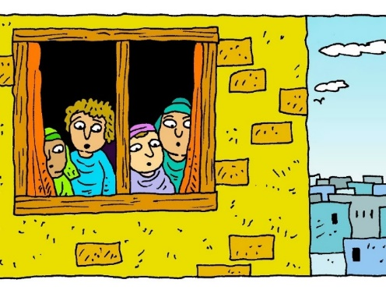
The Story of Pentecost

When the day of Pentecost had come, Jesus’ friends were all together in one place in Jerusalem.

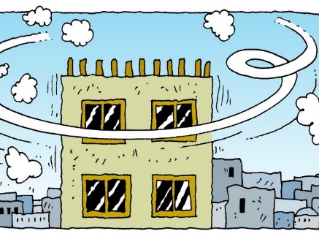

And suddenly from heaven there came a sound like the rush of a violent wind, and it filled the entire house where they were sitting.
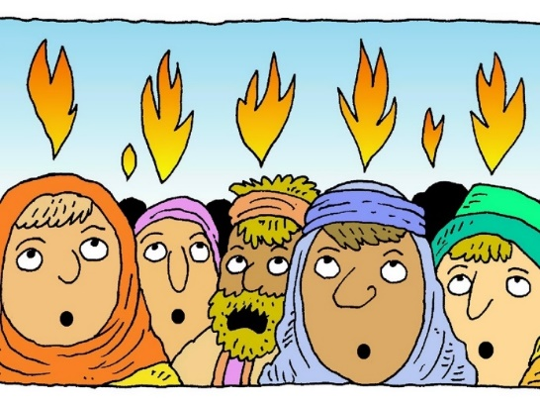

Divided tongues, as of fire, appeared among them, and a tongue rested on each of them.

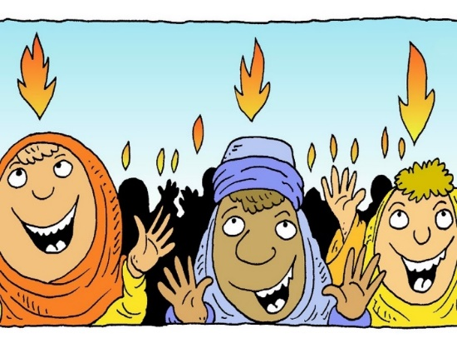
All of them were filled with the Holy Spirit and began to speak in other languages, as the Spirit gave them ability.

There were lots of Jews from many nations living in Jerusalem. And at this sound the crowd gathered and was bewildered, because each one could hear the disciples speaking in their own language.
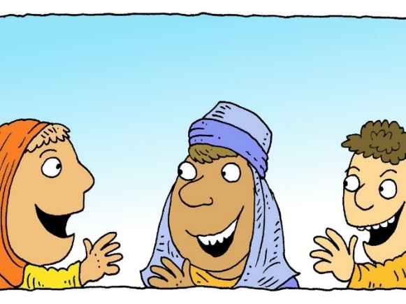
Amazed and astonished, they asked, "Aren’t these people all from Galilee? But we can hear them speaking in our own languages we hear them speaking about God’s deeds of power."

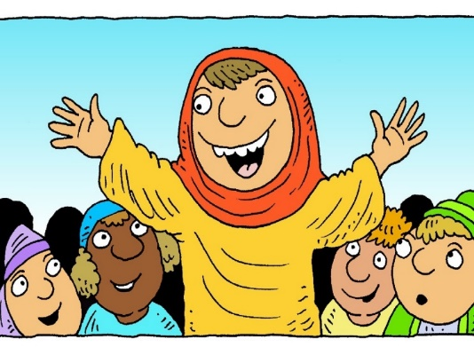
Peter, stood up and explained, this is what the prophet the prophet Joel spoke about. He said that God would pour out his Spirit on everyone.

